UOWD
Subject Code: CSIT321
Subject Name: Capstone Project
Submission Type: Planning & feasibility analysis
Project Title: Adaptiv
Student/Team Name: Omar Massoud, Abdallah Heggy, Ghina Ishaq, Hamza Al Raga
Bithin Radhakrishnan, Karylle Ochave
Student Number:7858681, 8457785, 871179, 7322586, 8910881, 7669057

Proposal Document – Outline
Background Info about topic............................................................................................................
Project Description and Objectives..................................................................................................
Overview.........................................................................................................................
System Experience.........................................................................................................................
Objectives......................................................................................
Project Scope....................................................................................................................................
Competitor solutions and their limitations........................................................................................
Target Niche.....................................................................................................................................
Pre-requisites...................................................................................................................................
Limitations.......................................................................................................................................
How we do it?...................................................................................................................................
High level system architecture..........................................................................................................
The high level system operation.......................................................................................................
Software and Hardware requirements............................................................................................
Software requirements.....................................................................................................................
Tools and platforms.......................................................................................................................
Hardware requirements...................................................................................................................
System setup hardware.................................................................................................................
Specialized hardware.....................................................................................................................
Challenges.........................................................................................................................................
Future Improvements.......................................................................................................................
Timeline.............................................................................................................................................
Gantt Charts.....................................................................................................................................
Project Management tools to be used...........................................................................................
Tools and platforms......................................................................................................................................
Team Work Distribution...................................................................................................................
References........................................................................................................................................

Background Info about topic

Cardiovascular diseases (CVDs) are the number one cause of mortality worldwide, as it is estimated that 17.9 million people die annually (World Health Organization, 2024). These diseases are coronary heart disease, stroke among others that involve heart and blood vessel diseases. Most of the CVDs are preventable with early screening, regular follow-up and lifestyle change but the problem is that most of the patients cannot receive long-term follow-up and real time feedback as a default in patient rehabilitation and prevention care.

With the development of technologies, the collection and analysis of health data is changing due to the emergence of Artificial Intelligence (AI), Internet of Things (IoT), and Big Data analytics. AI allows systems to identify the trends in the heart rate, oxygen levels, and blood pressure, giving predictive information about the cardiovascular functioning. Smartwatches and sensors are IoT devices that enable constant data gathering of the health condition in non-hospital environments, and cloud computing ensures safe storage and access to the data.

The Adaptiv Health project is a response to the increasing demands of smart cardiovascular care devices through the integration of these technologies to develop an adaptive system, which prevents cardiovascular risk and helps in post-recovery rehabilitation. It allows users to find out and take control of their heart health with the help of data-driven insights and personalized guidance, which is in line with the efforts of the world to incorporate technology in the healthcare and wellness system.

Project Scope
Adaptiv Health is an artificial intelligence-based cardiovascular support device that targets to support safe exercise, enhance the early risk factor identification and maintain long-term heart-health care. Unlike traditional fitness apps which focus on the performance measures (caloric expenditure or number of steps) of the app, Adaptiv Health is explicitly focused on preventive care and rehabilitative interventions. Its design enables its users, especially those who are at risk, or have a history of cardiovascular disease, to get tailored exercise prescriptions, real-time physiological monitoring, and continuous analytical reports on their cardiovascular performance.

The platform combines artificial intelligence and massive data analytics to analyze health indicators, such as heart rate, oxygen saturation, and blood pressure, as measured by wearable sensors. With the aid of longitudinal user data, Adaptiv Health dynamically matches the intensity of workouts, periods of rest and recovery plans to match each cardiovascular tolerance of an individual. The system allows users to make evidence-based choices about their physical activity through the integration of Internet-of-Things wearable devices and secure cloud computing, and at the same time, the system will reduce the risks of overexertion or cardiac strain.

The adaptivHealth program includes the design, development, and testing the following elements:

- User registration, health data entry and progress visualization mobile and web interface.
- Connection with commercial wearable IoT devices (e.g., Fitbit, Apple Watch) or simulated sensors to obtain real-time heart-rate data and oxygen-saturation data.
- Artificial intelligence-based analytical functional unit that defines the baseline cardiovascular conditions and creates safe heart-rate zones.
- Dynamic activity suggestions, such as low-impact exercise, guided breathing and walking plans, individually adjusted based on the cardiovascular status of the user.
- Data security, scalability, and adherence to health-information regulations (HIPAA, GDPR) - Cloud-based storage and analytics infrastructure.
- Summary reports on heart-rate trends, recovery period and performance indexes in post-session reports and dashboards.
- Adaptive learning, a type of machine-learning that improves recommendations with more data as the data are accumulated.

Out of Scope

- Direct medical diagnosis or therapeutic intervention. The medical diagnosis or therapeutic intervention must be forced by policy as an adjunctive, not directly substitutive, tool to professional medical advice.

- Integration with clinical-grade ECG devices or electronic health record systems (as a potential future improvement).

- Automated emergency medical response, such as real time notification to clinicians or emergency services.

- Predictive modeling of rare or more complicated cardiac disorders which would require special clinical validation.

Target Audience

Adaptiv Health targets a wide but health-conscious market having particular cardiovascular needs.

Primary Users:

- Mild and moderate cardiovascular patients like hypertension, arrhythmia, or post-cardiac-event rehabilitation.

- Grown-ups who have the interest to take preventive action against cardiovascular disease, with age 35 to 70.

- Patients who are recuperating cardiac surgery or undergoing rehabilitative programmes whose activities require supervision and safe guidelines.

Secondary Users:

- Physical therapists, physiotherapists, and fitness trainers are healthcare specialists who may need secure patient data tracking.

- Scholars and health promotion agencies that research cardiovascular behaviour and recovery trends at the population level.

- With a focus on users who require guidance as opposed to intensity, Adaptiv Health fills a very vital niche between high-performance fitness apps and clinical monitoring systems.

Competitor Analysis

Competitor | Focus | Limitations | Adaptiv Health Advantage
Fitbit Premium | Fitness tracking, wellness measurements | No cardiovascular-specific safety instructions | Personalized AI heart rate safety algorithms
Apple Fitness+ | On-demand workouts and progress reporting | Standardized workouts, no condition-specific workouts. | Specific exercise programs are modified to promote cardiovascular safety.
Withings Health Mate | Blood pressure and heart tracking | Data collection only, no adaptive AI | Combines a continuous health control with exercise protocols development that meets the safety standards.
Qardio | Clinical-level  Blood-pressure monitoring | No activity instructions, limited to tracking | Integrates organized medical care with preventive exercise.
Cardiogram App | Detection of heart anomalies | No personalized adjustment of exercise to the patient. | Uses a continuous learning that relies on AI to support safe cardiac exercise.

Key Differentiator:

Although the majority of competitors focus on overall fitness or health tracking, Adaptiv Health is the only company to integrate AI-based adaptive training with cardiovascular safety features, which will provide every activity with compliance with the present cardiac condition and recovery ability of the user.

Limitations

- Hardware Accuracy: The quality of wearable devices determines the precision of sensors; inaccurate signals can affect the accuracy of the analytics.

- Environmental Factors: Stress, sleep deprivation, hydration, and temperature variations are factors that may affect physiological data.

- Regulatory Restrictions: Clinical validation and medical certification requires new trials and joint ventures.

- Reliance on Connections: Real-time monitoring is reliant on internet and Bluetooth connectivity.

- User Compliance: The efficiency of the system depends on the regular usage and adherence of the sensors.

Prerequisites

Adaptiv Health will require the following technical and operational requirements to achieve the implementation:

- Wearable sensor connection by Fitbit or Apple HealthKit APIs or similar IoT health devices.
- Cloud infrastructure security (e.g., AWS, Azure, Google Cloud) to ensure scalability and encryption of data.
- Python, TensorFlow, or PyTorch machine-learning models used to train AI models.
- Cross-platform mobile front-end development with React Native or Flutter.
- RESTful API back-end services are created with Node.js or Django to guarantee the secure exchange of data.
- Information security in compliance with HIPAA and GDPR regulations on medical information processing.
- Built-in ethical and transparent data collection consent.

The reason why the System is interested in Cardiovascular Safety.

The philosophy of Adaptiv Health is based on the idea of safety-first cardiovascular care. Cardiovascular disease is the leading cause of death in the world; although physical activity cannot be avoided in preventing and recovering, it is dangerous in case of insufficient monitoring. Most of them, especially the post-recovery stage, have no access to customized instructions that ensure that they construct the activity within the safe physiological limits.

Key motivations include:

- The avoidance of cardiac overload: The spike in heart-rate or oxygen deprivation can be lethal in high-risk patients; AI-based monitoring will reduce these risks.
- In favor of rehabilitation: Cardiac event recovery patients need a specific endurance recovery, supported through adaptive feedback.
- Enabling self-control: With practical insights, the users will be able to make changes in their lifestyles without having to be under continuous clinical supervision.
- Closing the divide: The system bridges clinical healthcare and daily fitness such that the wellness technology fosters safety and not just activity.
- Long-term monitoring: Data analysis on a regular basis can show early warning signs prior to the appearance of symptoms, and early prevention can take place.

Adaptiv Health is not just a fitness app but a digital cardiovascular companion that helps to manage the heart-health experience in a safer, smarter and sustainable way.

Expected Impact

By introducing Adaptiv Health, the project aims to:

- Increase cardiovascular awareness and education amongst users.
- Reduce the risk of cardiac events that occur during exercise.
- Create a scalable online preventive heart care.
- Invest in the international digital health and AI-driven wellness programs.
- Operate as a study site in terms of time-based population-level pattern analysis of cardiovascular conditions.

Gantt Chart
Duration: October 2025 – March 2026
Trimesters:

Trimester 1 (Autumn 2025): October – December 2025
Trimester 2 (Winter 2026): January – March 2026

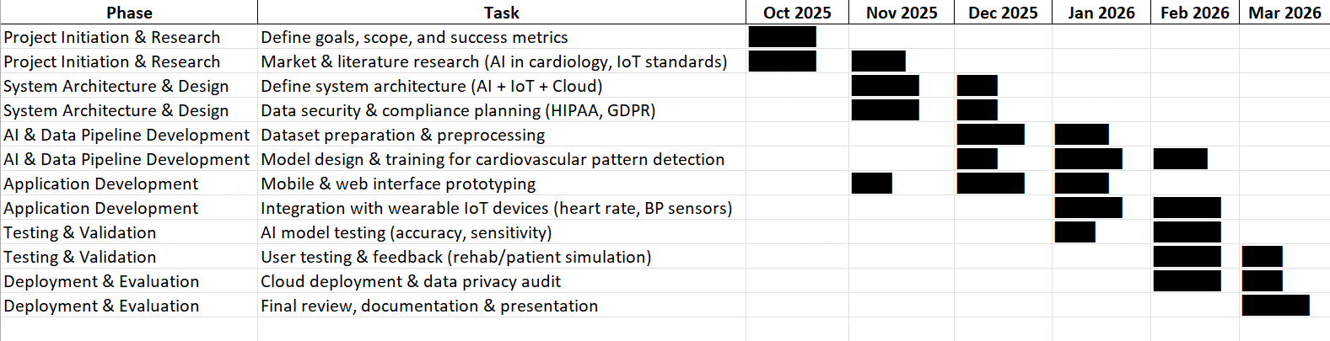

Project Description and Objectives

Project Overview
Adaptiv Health is an artificial intelligence cardiovascular health app which is aimed at assisting patients with heart diseases or people who might develop them. It makes use of actual data from reputable medical archives like the PhysioNet and the Kaggle Cardiovascular Disease datasets in order to prepare machine-learning models that can detect cardiovascular patterns. These models customize exercise and recovery training programs according to the user's vital, historical and behavioral patterns.

System Experience:
The interaction between the users will be on the basis of a mobile application and a web-based dashboard will be used to ensure that the user can access it and have access to analytics readily. When registering, users enter their medical information and enable wearable devices streamlining real-time heart rate and oxygen rates. This information is examined by the AI system on a daily basis and results in individualized suggestions, such as the duration during which it is safe to exercise, the optimal heart-rate range, or restoring activities. Whereas real-time adaptive alerts are the optimal final target, the present implementation will be concentrated on providing daily plans tailored to the specifics of the personal analysis of the ongoing data.

Objectives
- To create and model an AI based cardiovascular monitoring system with real patient data.
- To offer custom exercise and recovery initiatives that are responsive to the heart condition and progress of a user.
- To incorporate the IoT, cloud, and AI into a hybrid (mobile web) system to make it more accessible and synchronize data.
- To make sure that user data is secured and transferred safely and ethically and privately.
- To support preventive care provision through the provision of practical information that enhances cardiovascular awareness and protective measures.
Combining AI smarts with clinically-acquired information and contemporary software development, Adaptic Health can transform the process by which individuals can keep track of their heart health not as a patient, but as an empowered user of their recovery and wellness process.

How We Do It

System Architecture (IoT → Cloud → AI → Dashboard)
Wearable IoT sensors, secure cloud infrastructure, advanced AI analytics, and an interactive dashboard are linked on the integrated, layered architecture of Adaptiv Health. Its architecture is designed to offer high-performance continuity, constant heart monitoring, and safety of patient data.

1. IoT Layer (Wearables & Mobile Gateway)

The system begins by using wearable IoT sensors, including optical heart-rate and SpO2 sensors, which include Fitbit, Apple Watch, or custom ESP32 modules. Such devices will be able to constantly gather important data like:
- Heart rate (BPM) for activity intensity
- Blood oxygen level (SpO₂) for oxygen circulation efficiency
- Blood pressure (BPs/BPd) for cardiac workload estimation
The data is received by the smartphone application of the user, which is used as an edge gateway via Bluetooth Low Energy (BLE). Once some basic safety checks (i.e., false readings or sensor noise) have been done, the software saves the information and transmits it to the cloud to be further analyzed.

2. Cloud Layer (Data Management & Integration)
The cloud layer handles all the data collection, safe storage, and cross-component communication. It is founded on the cloud services that are HIPAA-compliant, such as Azure IoT Hub, AWS HealthLake, and Google Firebase.
Key cloud functions include:
- Real-time data streams processing data streams to perform continuous monitoring.
- Time-series databases that archive past data to be used to analyze long-term patterns.
- Secure APIs that limit access to data to certified medical workers or carers.
- Role-based authorization and authentication of users with encrypted logins.
This architecture is scalable, which means that it can support always-available processing without requiring much computing power on the device of the user.

3. AI Analysis Layer (Decision & Learning Engine)
The intelligence at Adaptiv Health is based on the AI module. It forecasts safe activity limits and cardiovascular rhythms interpretation through reinforcement learning and a supervised algorithm.
Core AI functions:
- Baseline learning: computes the average heart-rate range of each user when at rest and during an activity.
- Risk classification: identifies whether the cardiovascular risk of the user is low, moderate, or high.
- Adaptive suggestions: dynamic suggestions are workouts that adapt depending on previous workouts, including the duration and recovery.
- Abnormality development: sound an alarm on abnormal measurements (arrhythmia, low SpO2, high BP) to be investigated.
The AI model is constantly retrained on the updated user data over time in order to increase customization and predictive accuracy.

4. Dashboard & User Interface Layer
Dashboard is the primary means of communication between the system and the user. It can be accessed with the help of the internet and mobile applications.
Features include:
- Real-time monitoring: color-coded indicators (green = safe, amber = approaching limit, red = risky).
- Instant alerts: haptic or voice notifications when readings exceed safe limits.
- Session summaries: time in target zone, peak heart rate, recovery duration, and calories burned.
- Progress visualization: trend graphs showing improvement in cardiovascular stability.
- Cloud sync: data automatically saved and accessible to healthcare professionals if permitted.

Workflow and User Interaction
- User Onboarding & Setup: The user puts on their wearable device, creates an account, and fills out their cardiovascular history and demographics. The app takes a short guided setup to calibrate the device and ensure that the sensors are connected.
- Baseline Collection Phase: During the first 3-5 days, the system will capture normal activity data so as to create an individualized resting heart-rate profile and safe thresholds.
- AI Analysis & Classification: When the analysis of the base data is done, the AI model classifies the condition of the user (e.g., moderate-risk). Then, it develops a first training regimen which focuses on safe and mild cardiovascular exercise.
- Live Monitoring During Exercise: It measures the heart rate and oxygen levels in real-time during exercise. These can be visualized in real time using the mobile app, and an immediate alert message is sent to the user when the values become dangerous.
- Adaptive Response & Alerts: Once the heart rate goes too high, the app emits a real-time voice or on-screen message (Slow down - above safe zone) to increase or decrease the rest of the workout intensity.
- Post-Session Summary: At the end of every session, the user is provided with a detailed health report of the average heart rate, recovery time, and time spent in the target zone.
- Learning & Adjustment: The AI model takes into account every session and improves suggestions in the future, days of rest, and types of activity.
- Cloud Storage & Access: The data on every session is ultimately stored and encrypted in the cloud to be viewed, tracked, or shared with clinicians in the long term.
High-Level Operation Summary:
Wearable Sensors → Mobile App → Cloud Infrastructure → AI Model → Dashboard Feedback → User Action → Continuous Learning Loop

How the Design Ensures Feasibility
- It was constructed with all the available technologies, such as Python, TensorFlow, Firebase, Flask, and Mediapipe, to integrate the IoT and AI.
- Cloud-based design minimizes hardware dependency and cost.
- System modularity gives the team members the ability to build each component concurrently.
- Real-time alerts rely on edge AI (mobile processing) to minimize latency, ensuring user safety even without a stable internet connection. Alerts are provided in real-time and are based on edge AI (mobile processing) to reduce the latency and keep the user safe in case of a lack of a stable internet connection.

Software and Hardware requirements

Software Requirements:
Adaptiv Health has multifaceted technical requirements to meet its level of complexity that can be discerned only through proper analysis and research. After thorough research there are some software’s that we trust to bring about the technical flamboyance that would output the desired results we expect. It ranges from languages like python to Amazon web services for cloud computing. We have detailed the need, features and limitations in the sections to follow.

Backend: Development & AI Technologies
- Python 3.13 + TensorFlow 2.20.0 Ecosystem
Python is an Universal computer language accepted by healthcare and is HIPAA compliant with a large range of supporting libraries together with a TensorFlow ecosystem that powers the AI brain to analyze and make predictions for users. TensorFlow framework's LiteRT Runtime enables 15ms inference times which is critical for real-time cardiac monitoring on mobile devices.
Python library:
- Scikit-learn 1.5: to the local simple machine learning that does not require deep machine learning.
- KNNImputer: A scikit-learn class that imputes the missing values with the nearest neighbors.
- Pandas/NumPy: To analyze tabular and time-based data. Numpy facilitates the computations of math whereas Pandas structures data in tables.
AI architecture in Cardiac-Specific Applications Long Short-Memory Cardiac-Specific Long Short-Memory memory networks and cardiac-specific detectarrhythmia Proposals on PPG signals; Convolutional neural net and arrhythmia detection on ECG signals; Reinforcement learning and optimizing personalized exercise prescription. It will be operated on Edge AI that will be used in local detection and is faster than cloud AI but will also work on cloud AI that will train data on a mass scale and make complex analytical decisions.

Frontend Technologies
Flutter 3.24 (Patient Mobile App)
Flutter shows the best performance in real-time health monitoring applications, especially, in the complicated visualization of cardiovascular data, which is HIPAA-compliant. Key advantages include:
- Live heart rate graphing performance at 60 fps.
- Offline-first architecture that does not lose essential safety functions with the loss of connectivity.
- Wearable device communication with Native Bluetooth Low Energy 5.3.
- 95 percent of development time saved (iOS/Android) through cross-platform deployment.

React 19.2 (Doctor Dashboard)
The latest 19.2 version supports Activity Component which preloads data and helps switch between statistics faster while sticking only relevant information from the servers thus protecting patient data. Also display a list of patient info and alerts for patients with a concerning heart rate pattern. Helps doctors to review workout history and adjust routines remotely.
Database & Cloud Infrastructure
Hybrid Architecture (Firebase + AWS)
Critical October 2025 Update: Firebase alone is NOT HIPAA-compliant. Recommended architecture:
- Firebase/Firestore: Real-time synchronization for non-PHI data when needed. Like a workout routine or step count.
- AWS RDS PostgreSQL: HIPAA-eligible storage for Protected Health Information with Business Associate Agreement. Such as patient medical records, heart conditions and medications.
- AWS EC2 (C8/R7 instances): It runs in backend servers and processes data and server APIs. There is vital data uploaded daily from the user to the larger cloud AI model. It calculates health score data which are too complex for phones to run locally.
Configuration: Firebase owned by Google requires Google Cloud Platform Business Associate Agreement setup for HIPAA compliance; AWS services (EC2, RDS, S3) are automatically HIPAA-eligible under AWS BAA.
Monthly Cost (100K users): $4,600 (AWS) + $200 (Firebase) = $4,800 total.

Other Project Tools
- Postman: a widely used API in health tech that will make sure that only data that is relevant is provided. In other cases, developers use it to design, test and document APIs.
- VS Code Python/Dart/JavaScript integrated development environment.
- GitHub: Version control in order to allow teams to collaboratively work without stepping on one another with storage through Git LFS(large file storage) of large AI weights.
- Figma HIPAA-accessible UI/UX designed to comply with WCAG 2.1 accessibility.

Security software stack

- Endpoint detection: CrowdStrike Falcon is HIPAA-certified and ensures end to end protection for patient devices and medical personnel systems. Protects against phishing and ransome attacks.
- Cloud Security: Zscaler or Prisma Cloud protects Firebase and AWS cloud environments with active threat scanning, encrypted tunnels, and access segmentation controls.
- Data Loss Prevention: ManageEngine DLP+ would ensure patient health data from Adaptiv’s app, reports, and hospital dashboards cannot leak through human error or insider misuse.
- AI Threat Detection: Darktrace ActiveAI adds an “immune system” for the digital infrastructure, automatically identifying and neutralizing abnormal cloud or IoMT (Internet of Medical Things) behavior before damage occurs like an unpermitted download of patient data at 3 am.
- Risk Management & Compliance: Censinet RiskOps automates HIPAA compliance culture that anticipates vulnerabilities in hospital partnerships, wearable data exchanges, and cloud vendors.
- Backup & Recovery Layer: AWS S3 Object Lock + Immutable Snapshots Protects backups against ransomware or corruption by allowing patient recovery histories and making copies.

Hardware Requirements:
Adaptiv Health is based on a series of secure, interoperable hardware which enables cardiovascular monitoring and communication of patient, mobile and cloud data to be accurate and safe. The hardware ecosystem of the system should allege accuracy, portability, and privacy, particularly because a number of the users will be handling heart conditions.
Wearing and Sensing Devices
At the user level, the platform is interconnected with commercially available wearables including the Fitbit Charge 6, Apple Watch Series 9, or Polar H10 chest straps that are medically certified. These monitors record physiological data, such as the heart rate (HR), heart-rate variability (HRV), and blood-oxygen (SpO2) using optical or electrical sensors. In case of experimental/low cost deployments, the same values can be simulated by using an ESP32 microcontroller with a MAX30102 photoplethysmography (PPG) sensor. The sensors all have Bluetooth Low Energy 5.3, which offers a stable transmission with a small battery consumption.
Edge and Mobile Processing
The smartphone of each user is an edge-computing node, with an implementation of a lightweight TensorFlow Lite model which runs on-device safety and risk scoring checks and scores before any data is sent out of the phone. This design does not only decrease latency, it also minimizes the information that would be identifiable to the cloud.
Cloud and Networking Infrastructure
The back-end services will be implemented using AWS EC2 instances and an RDS PostgreSQL cluster that will be used in a HIPAA-eligible Virtual Private Cloud (VPC). The clinician access to the dashboard and communication between servers and devices is safeguarded by VPN gateway and TLS 1.3 encryption, respectively. The development and testing will be based on regular laptops (at least 8 GB RAM, SSD drive) which will be connected to a stable broadband network to simulate the real-time data flow.
System Security Hardware
Additional, non-obligatory but advisable items are a Hardware Security Module (HSM) or AWS Key Management Service to store the keys, and router-level firewalls to avoid unwarranted incoming traffic. These are combined to produce a sensor to clinician dashboard encrypted loop.

Challenges

Technical Challenges
- Real-Time Latency for Critical Safety Alerts
Problem: Patient safety requires <1-second response when heart rate exceeds safe thresholds or arrhythmia detected. Traditional cloud processing introduces 1.3+ second latency.
Solution: Edge AI Architecture with TensorFlow Lite which is 13x times faster than cloud. Wearable device to phone 50ms, AI processing 100ms, local alert generation 10ms which is a total of 160ms max.
Implementation: Quantized TensorFlow models (<50MB) deployed via Flutter app enabling offline safety monitoring. Cloud processes non-time-critical tasks (daily health scoring, trend analysis).
- System Scalability
Problem: Support 10,000 concurrent workout monitoring sessions plus 100,000 daily health score calculations without performance degradation.
Solution: Multi-Tier AWS Auto-Scaling Architecture.
Performance Standards:
API Response: <200ms (p95), <500ms (p99), Database Write Latency: <50ms, System Uptime: 99.9%.

Data Challenges

- Data Quality & Missing Values
Problem: Wearables can go missing due to lack of usages or batter loss. Such gaps can create bad data. Solution: Multi-Stage Validation Pipeline.
We need to check if readings are well within safe range or at least possible range. Our tech should also detect obvious sensor errors like a heartbeat jump from normal to astronomical scale. The KNNImputer library uses statistical imputation to fill gaps and ignore days with too much missing data. The cloud AI should be able to absorb and learn patterns from a bigger audience to understand larger gaps.
Imputation strategy:
- Short gaps (<5 min): Linear interpolation
- Medium gaps (5-30 min): KNN imputation during activity
- Long gaps (>30 min): Flag as missing, exclude from training

- Synthetic Data Training Limitations
Problem: It is presently hard to gain access to real life cardio data SO relying on synthetic data can provide statistics that may not be as realistic or accurate. Solution: Progressive Real-World Integration (with FDA approval). Over long time use of the app by a larger group of people can provide essential and crucial data that can be used for machine learning. The first two weeks are a learning phase for the edge AI to personalize the health status to the user.
Ideal scenario:
Phase 1 :80% synthetic + 20% real (proof-of-concept, NOT deployed)
Phase 2 :50% synthetic + 50% real (hospital pilot, 1,000 patients)
Phase 3 :100% real data (production deployment)

Security and Ethical Problems.

Constructing an AI-based health platform implies a challenging complex of technical, ethical, and legal risks. My area of interest as the cybersecurity lead is that the innovation of Adaptiv Health should not jeopardize patient safety or trust.

Data Privacy and Compliance

The key issue is that it is necessary to address the Protected Health Information (PHI) and comply with HIPAA and GDPR. Sensitive data should be encrypted during transmission (TLS 1.3) and rest ( AES-256). Only the HIPAA-eligible AWS services will be used to store patient records anonymously. Data Protection Impact Assessments (DPIAs) will be conducted to ensure that the practice of handling data is in line with the international standards (HIPAA Journal, 2024; European Commission, 2024).

Authentication and Access Control

Since various roles such as patients, clinicians, and administrators, get involved in the system, access control is another issue. The use of OAuth 2.0 and OpenID Connect as well as role-based access control (RBAC) will ensure that unauthorized data exposure does not occur. Rotating tokens are done periodically and all attempts of access are logged to aid in auditing.

Ethical AI and Transparency

The AI suggestions regarding the intensity or rest of exercises might be confused with medical guidance. To avoid excessive dependence on algorithms, the interface of Adaptiv Health will have obvious disclaimers and call-your-doctor functions in case of abnormal reading. The scoring model will be interpretable, demonstrating what metrics had an impact on an outcome to make informed decisions and clinical supervision (Amann et al., 2020).

User Consent and Control

The sustained observation brings up the issue of implicit consent. The user will be able to explicitly and revocably control data streams shared. The application will have privacy controls to put tracking on hiatus, will have an option of deleting the stored data or will export summaries to a physician, in accordance with the GDPR principle of a right-to-be-forgotten.

System Integrity and Security Assurance

It is vital to have integrity among the distributed devices. Any software changes will be signed and checked by cryptographic hash sums (SHA-256). Before every deployment phase, the penetration testing and vulnerability scans will be conducted. This multi-level strategy is a guarantee of regulatory compliance and user trust with regard to the safety of the system.

Future Improvements

- ECG Integration: Provide an option of adding single-lead ECG sensors to allow detection of arrhythmia and irregular heart rhythm so that clinicians receive a more accurate diagnostic assistance.
- Predictive Risk Alerts: Have predictive algorithms that predict cardiac or overexertion based on historical vitals, environmental and the type of activity.
- Healthcare Provider Partnerships: Provide protected clinician portals that give physiotherapists or doctors a chance to check patient progress and revise exercise plans remotely.
- Expanded IoT Ecosystem: Add new devices, including Garmin, Samsung Health, and medical-grade blood-pressure monitors.
- Voice and Virtual Coaching: Add AI voice coaching to provide hands-free coaching (“Heart rate too high - take a 30-second break”).
- Federated Learning Model: Machine learning should be done on user devices so that the training process is more personalized without exposing user-specific health information, which improves privacy.
- Community and Rehab Programs: Partner with hospitals and fitness centers to provide Adaptiv Health as a component of cardiac-rehab programs.
- Clinical Validation & Certification: Find collaboration with pilot studies to obtain medical-device compliance (i.e., FDA or CE Mark).

Project management tools to be used

Adaptic Health team will follow semi-Agile project management style, with flexibility, collaboration and continuous feedback but with definite milestones. It will follow Agile development principles, which include iterative development and reviews conducted after each sprint, without the formal rigidity of complete Scrum processes.

Tools and Platforms:

GitHub: A version control, code collaboration and issue tracking tool. It allows employees in a team to combine their efforts and test them effectively as well as have a single codebase.

Google drive: main storage of shared documentation, that is, reports, diagrams, and meeting notes. This would guarantee that the members are in synergy with the current materials.

Google meet and WhatsApp: Main communication tools to use, weekly online meetings, and coordination.

Canva / Google Slides: To make presentations and document visually as an update on the progress.

Team Coordination

Every stage of the project will also have established deliverables and internal deadlines to have project progress in line with the CSIT321 timelines. The roles and responsibilities have been defined to evenly spread out the technical, analytical and documentation workloads among all the six members. Scheduled meetings with the designated mentor and project supervisor on a weekly basis will enable the team to overview the milestones, solve problems as they come by and modify plans accordingly.

This architecture encourages transparency, accountability, and continuous improvement which are important parameters in producing a project of both academic rigor and professional software development standards.

Diagrams:

Figure 1. Use Case Diagram — Adaptiv Health System

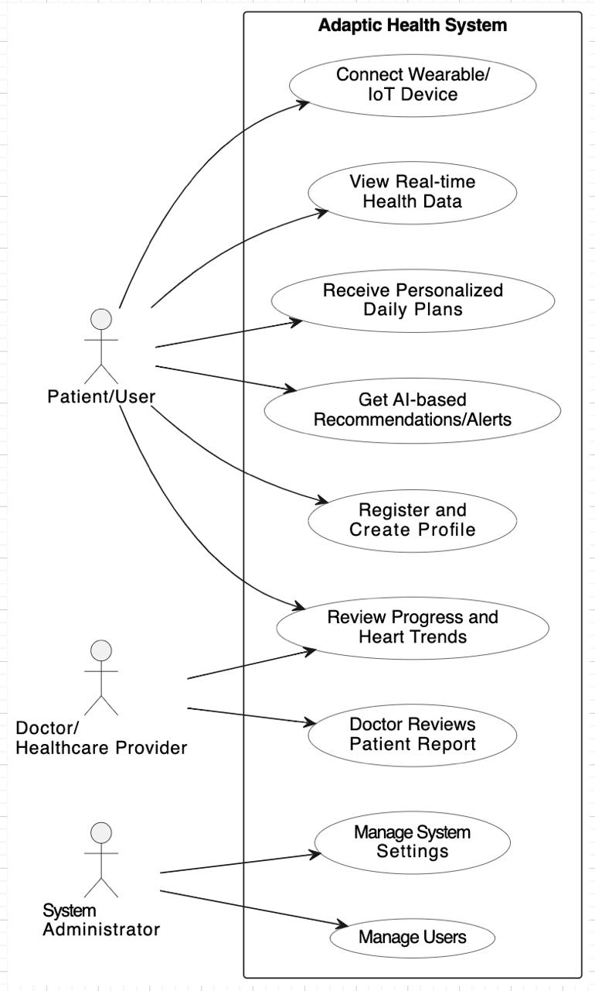

Figure 2. Sequence Diagram — Real-Time Monitoring and AI Feedback Flow
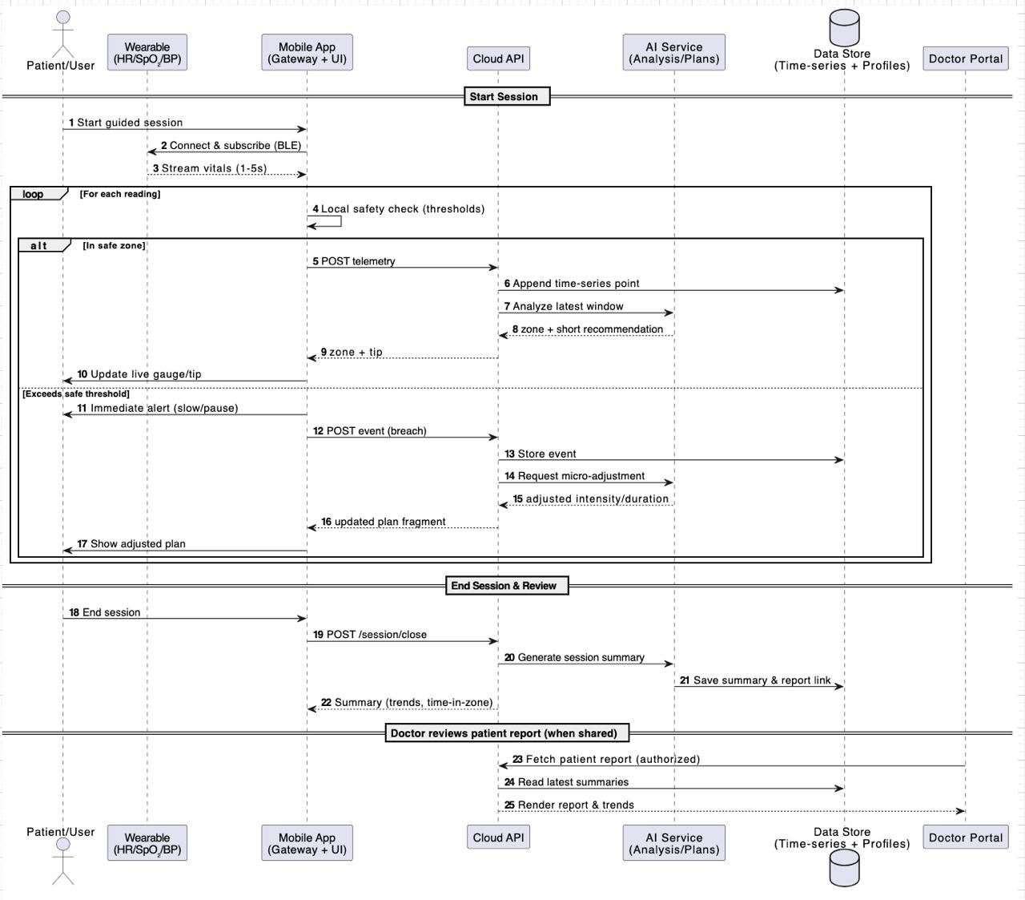

Figure 3. Component Diagram — System Architecture Overview
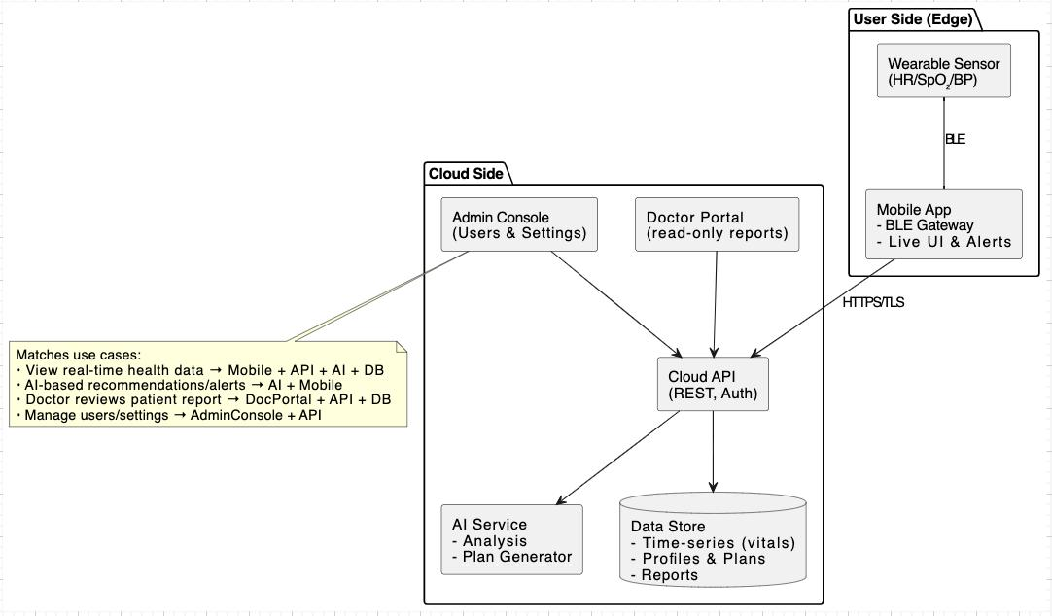

Figure 4. Deployment Diagram — Runtime Environment and Data Flow

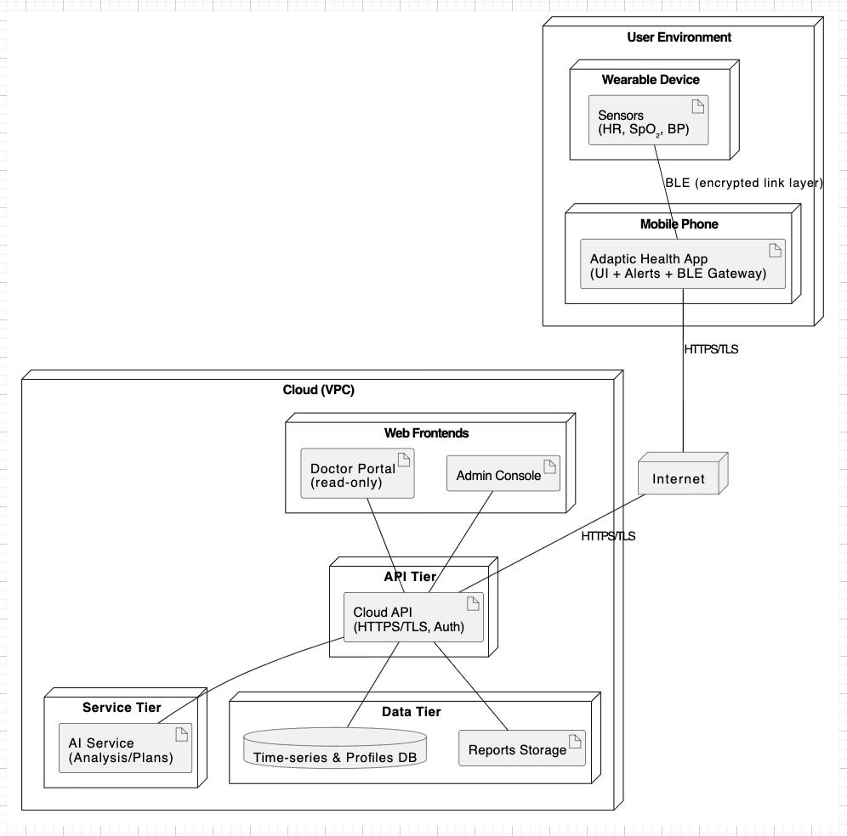

Teamwork Distribution

Members | Specialization | Primary Responsibilities | Key Deliverables
Omar Massoud (7858681) | AI and Big Data | Training of the adaptive AI engine using real cardiovascular data; development and design of machine learning models to make predictive health recommendations. | Algorithms, data flows and trained AI models.
Abdallah Heggy  (8457785) | AI and Big Data | Data preprocessing, cleaning, and management of actual patient datasets (PhysioNet, Kaggle, etc.); analytics to generate plans on a daily basis. | Scripts on data management, data visualization and a model evaluation report.
Bithin Radhakrishnan  (8910881) | Cybersecurity | Introduction of data encryption and secure communication between IoT devices, cloud servers, and the app; making sure that the standards of healthcare data are adhered to. | Architecture, encryption modules and privacy compliance documentation.
Hamza Al Raja  (7322586) | Cybersecurity | Risk evaluation and vulnerability testing of the application; creation of user authentication and access control systems. | Security test reports, authentication modules and compliance summary.
Karylle Ochave  (7669057) | Business information systems (BIS) | Market research, analysis of feasibility, and schedule of the project; creating Gantt charts and project documentation. | Project timeline, feasibility report sections, and business case.
Ghina Ishaq  (8711719) | Computer Science - General | Combination of AI, IoT, and cloud elements; development of the hybrid mobile-web interface and upkeep of project documentation. | Working prototype, integration plan, final documentation and system diagrams.

References:

- Elvas, L.B., Almeida, A. & Ferreira, J.C. (2025) ‘The Role of AI in Cardiovascular Event Monitoring and Early Detection: Scoping Literature Review’, JMIR Med Inform, 13, e64349. Available at: https://medinform.jmir.org/2025/1/e64349

- Bhaltadak, V. et al. (2024) ‘A Comprehensive Review on Advancements in Wearable Technologies: Revolutionizing Cardiovascular Medicine’, PMC – NCBI, PMC11212841. Available at: https://pmc.ncbi.nlm.nih.gov/articles/PMC11212841/
- Amann, J., Blasimme, A., Vayena, E., Frey, D., & Madai, V. I. (2020). Explainability for artificial intelligence in healthcare: A multidisciplinary perspective. BMC Medical Informatics and Decision Making, 20(1), 310. https://doi.org/10.1186/s12911-020-01332-6
- HIPAA Journal. (2024). Best practices for HIPAA-compliant cloud storage and transmission. Retrieved from https://www.hipaajournal.com/
- Food and Drug Administration (FDA). (2024, December). AI/ML-enabled medical device guidance. U.S. Department of Health and Human Services. https://www.fda.gov/
- AddWeb. (2025, October 23). Python AI libraries 2025. Retrieved from https://www.addwebsolution.com
- AWS Healthcare Blog. (2025, September 21). Agentic AI healthcare. Amazon Web Services.
- European Commission. (2024). Guidelines on artificial intelligence and data protection: GDPR compliance in healthcare applications. Publications Office of the European Union.
- Stanford Medicine. (2024, September 2). Synthetic data in healthcare: Opportunities and risks. Stanford University Press.
- World Health Organization. (2024) Cardiovascular Diseases (CVDs): Key Facts. WHO. Available at: https://www.who.int/news-room/fact-sheets/detail/cardiovascular-diseases-(cvds)
- Goldstein, B., Saeed, M. & Mark, R.G. (2023) MIMIC-IV: A Freely Accessible Critical Care Database for Artificial Intelligence and Data Science Research, PhysioNet. Available at: https://physionet.org/content/mimiciv/

